Assessment Schedule – 2013

Music: Demonstrate understanding of two substantial contrasting music works (91277)

Evidence Statement
Notes
- The requirement in Question One to include evidence from or reference to the score must be treated in light of the fact that the candidate is not permitted to bring musical scores into the examination; all musical evidence presented must be assessed holistically.
- Sample responses to each question are provided in the Appendix.

Question | Evidence
ONE | Elements and features of a scored work
(a) | Explains THREE ways that timbre and / or instrumentation are important features of the work as a whole.
(b) | Explains how TWO of three elements (form / structure, melody, and rhythm) are used as important features of the work, and evaluates the effect of the use of the features within the work as a whole.

N1 | N2 | A3 | A4 | M5 | M6 | E7 | E8
Attempts to explain ONE way that timbre or instrumentation is used in the work | Attempts to explain ONE way that timbre or instrumentation is used in the work | Briefly explains TWO ways that timbre or instrumentation are used in the work, supported by simple musical evidence | Briefly explains TWO ways that timbre or instrumentation are used in the work, supported by simple musical evidence | Explains in depth TWO ways that timbre and / or instrumentation are important features of the work, supported by specific musical evidence | Explains in depth TWO ways that timbre and / or instrumentation are important features of the work, supported by specific musical evidence | Comprehensively explains THREE ways that timbre and / or instrumentation are used in the work as a whole, supported by precise musical evidence from the score | Comprehensively explains THREE ways that timbre and / or instrumentation are used in the work as a whole, supported by precise musical evidence from the score
OR  Attempts to explain ONE feature of the work. | AND  Attempts to explain ONE feature of the work. | OR  Briefly explains how ONE element is used as a feature of the work, supported by simple musical evidence. | AND  Briefly explains how ONE element is used as a feature of the work, supported by simple musical evidence. | AND  Explains how ONE element is used as an important feature of the music, supported by specific musical evidence. | AND  Explains how TWO elements are used as important features of the music, supported by specific musical evidence. | AND  Evaluates the effect of the use of ONE important feature in the work as a whole, supported by perceptive musical evidence. | AND  Evaluates with insight the effect of the use of TWO important features in the work as a whole, supported by a range of perceptive musical evidence.
N0= No response; no relevant evidence.

Question | Evidence
TWO | The historical / social / cultural context of a work with or without a score
(a) | Identifies THREE features of the work that are typical of the genre / style / period.
(b) | Explains in detail how TWO of these features have been used in the work, and evaluates the importance of the features in showing that the music is representative of the genre / style / period.

N1 | N2 | A3 | A4 | M5 | M6 | E7 | E8
Identifies TWO features of the work that are typical of the genre / style / period. | Identifies TWO features of the work that are typical of the genre / style / period. | Identifies TWO features of the work that are typical of the genre / style / period. | Identifies TWO features of the work that are typical of the genre / style / period. | Identifies TWO features of the work that are typical of the genre / style / period. | Identifies THREE features of the work that are typical of the genre / style / period. | Identifies THREE features of the work that are typical of the genre / style / period. | Identifies THREE features of the work that are typical of the genre / style / period.
 | Attempts to explain how ONE feature has been used in the work. | Briefly explains how ONE feature has been used in the work, supported by simple evidence. | Briefly explains how TWO features have been used in the work, supported by simple evidence. | Explains in depth how ONE feature has been used in the work, supported by specific evidence. | Explains in depth how TWO features have been used in the work, supported by specific evidence. | Comprehensively explains how TWO features have been used in the work supported by perceptive evidence | Comprehensively explains how TWO features have been used in the work, supported by perceptive evidence
 |  |  |  |  |  | Evaluates the importance of ONE feature in showing that the work is representative of the genre / style / period, supported by perceptive evidence. | Evaluates with insight the importance of TWO features in showing that the work is representative of the genre / style / period, supported by perceptive evidence.
N0= No response; no relevant evidence.

Question | Evidence
THREE | Discussion of both works
(a) | Explains how a factor (social / historical / cultural events, or resources available at the time) affected the first performance of one of the works.
(b) | Explains how an element (tonality or texture) is used in the other work.
(c) | Identifies an element, compositional device or performance technique used in BOTH works, and discusses ONE similarity or difference in the way it has been used in the works.

N1 | N2 | A3 | A4 | M5 | M6 | E7 | E8
Attempts to explain the importance of a contextual factor in the first performance of one of the works | Attempts to explain the importance of a contextual factor in the first performance of one of the works | Briefly explains the importance of a contextual factor in the first performance of one of the works, supported by simple evidence | Briefly explains the importance of a contextual factor in the first performance of one of the works, supported by simple evidence | Explains in depth the importance of a contextual factor in the first performance of one of the works, supported by specific evidence | Explains in depth the importance of a contextual factor in the first performance of one of the works, supported by specific evidence | Comprehensively explains the importance of a contextual factor in the first performance of one of the works, supported by perceptive evidence | Comprehensively explains the importance of a contextual factor in the first performance of one of the works, supported by perceptive evidence
OR  Attempts to explain how texture or tonality has been used in one of the works. | AND  Attempts to explain how texture or tonality has been used in the other work. | OR  Briefly explains how texture or tonality has been used in the other work, supported by simple evidence. | AND  Briefly explains how texture or tonality has been used in the other work, supported by simple evidence. | OR  Explains in depth how texture or tonality has been used in the other work, supported by specific evidence. | AND  Explains in depth how texture or tonality has been used in the other work, supported by specific evidence. | OR  Comprehensively explains how texture or tonality has been used in the other work, supported by perceptive evidence | AND  Comprehensively explains how texture or tonality has been used in the other work, supported by perceptive evidence
 |  |  |  |  |  | AND  Discusses ONE similarity or difference in the use of an element, device, or technique in the works, supported by perceptive evidence. | AND  Insightfully discusses ONE similarity or difference in the use of an element, device, or technique in the works, supported by perceptive evidence.
N0= No response; no relevant evidence.

Judgement Statement
 | Not Achieved | Achievement | Achievement with Merit | Achievement with Excellence
Score range | 0 – 8 | 9 – 13 | 14 – 19 | 20 – 24

Appendix – Sample Evidence
Question | Achievement | Achievement with Merit | Achievement with Excellence
ONE | Work: “Danseuses de Delphes”, “Voiles”, “La cathédrale engloutie”, “La fille aux cheveux de lin” from Préludes, Book 1  Composer: Claude Debussy  Genre / Style / Period: Impressionism
(a) | Brief explanation of ways that timbre or instrumentation are used in the work, supported by simple musical evidence. | In-depth explanation of ways that timbre and / or instrumentation are important features of the work, supported by specific musical evidence. | Comprehensive explanation of ways that timbre and / or instrumentation are important features of the work, supported by specific musical evidence.
 | Debussy uses the timbres of the piano to create in music the delicate colours and shades of light used by Impressionist painters. | Debussy uses the timbres of the piano to create in music the delicate colours and shades of light used by Impressionist painters.  He endeavoured to create in music what the Impressionist painters did in painting, with smooth fluid sounds and careful articulation used to create shades of colour throughout the piano.  This is shown in the typical three-part texture of the opening two bars of “Danseuses de Delphes”. | Debussy uses the timbres of the piano to create in music the delicate colours and shades of light used by Impressionist painters.  He endeavoured to create in music what the Impressionist painters did in painting, with smooth fluid sounds and careful articulation used to create shades of colour throughout the piano.  This is shown in the typical three-part texture of the opening two bars of “Danseuses de Delphes”, with the middle notes being brought out of the outer notes:  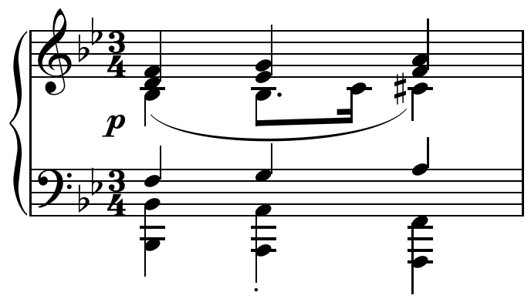
 | Debussy creates different timbral effects by having the piano play in different registers with very high and very low sections. | Debussy creates different timbral effects by having the piano play in different registers. He often contrasts very high sections and very low sections, as well as having wide gaps between the hands at the same time – for example, in the opening of “Voiles”. | Debussy creates different timbral effects by having the piano play in different registers. He often contrasts very high sections and very low sections, as well as having wide gaps between the hands at the same time. For example, in the opening of “Voiles” (bars 4–6), a high melody in the treble is contrasted with the low pedal on Bb:  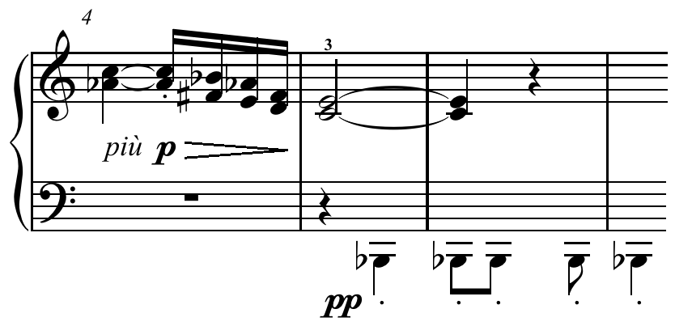

Question One cont’d
Question | Achievement | Achievement with Merit | Achievement with Excellence
 | He uses the pedal to create blurred effects, and often uses the soft pedal as much as the sustaining pedal. | He uses the pedal to create blurred effects and often uses the soft pedal as much as the sustaining pedal.  He also uses the soft pedal to help achieve the various shades of soft – for example, bars 18–20 of “Danseuses de Delphes” have the markings pp, più pp and ppp. | He uses the pedal to create blurred effects and often uses the soft pedal as much as the sustaining pedal.  He also uses the soft pedal to help achieve the various shades of soft – for example, bars 18–20 of “Danseuses de Delphes” have the markings pp, più pp and ppp.  In “La cathédrale engloutie”, Debussy begins with a chord that is separated in two parts that are separated by three-and-a-half octaves.
(b) | Brief explanation of how an element is used as a feature of the work, supported by simple musical evidence. | In-depth explanation of how elements are used as important features of the music, supported by specific musical evidence. | (Insightful) evaluation of the effect of the use of important feature(s) in the work as a whole, supported by perceptive musical evidence.
 | Melody  Often the melodies are built from short motifs and are fragmented. They are often doubled in thirds, have a narrow range, and are freely combined. | Melody  Often the melodies are built from short motifs and are fragmented. They are often doubled in thirds, have a narrow range, and are freely combined. A typical example is the opening of “Voiles”, where the range of the first motif is an augmented fourth, and the falling figure is doubled in thirds. | Melody  Often the melodies are built from short motifs and are fragmented. They are often doubled in thirds, have a narrow range, and are freely combined. A typical example is the opening of “Voiles”, where the range of the first motif is an augmented fourth, and the falling figure is doubled in thirds (see example above).
 | Some melodies are based around unusual scales, eg pentatonic in “La fille aux cheveux de lin”. | Some melodies are based around unusual scales. A good example is the pentatonic opening of “La fille aux cheveux de lin”. | The opening of “La fille aux cheveux de lin” is a good example of a Debussy melody with its pentatonic scale and repeated small motif and oscillating nature:  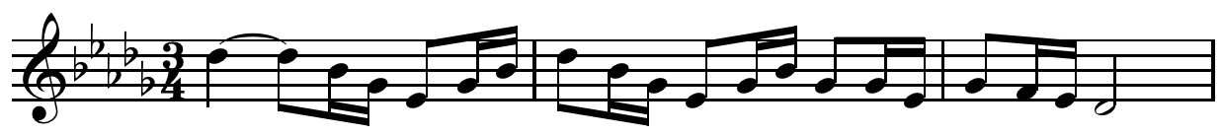
The opening of “Voiles” is based on the whole-tone scale.
The effect of using short motifs or fragmented melodies is similar to the use by the Impressionist painters of short brush-strokes –phrases are not clear-cut and balanced, but blurred.
 | Rhythm  Debussy often tries to smooth rhythms through stepwise movement, and uses many fast notes (such as demisemiquavers). He often contrasts this with dotted rhythms. | Rhythm  Debussy often tries to smooth rhythms through stepwise movement, and uses many fast notes (such as demisemiquavers) and dotted rhythms. In “Voiles”, the opening melody consists of a fast-moving stepwise rhythm contrasted with a dotted, leaping rhythm. | Rhythm  Debussy often tries to smooth rhythms through stepwise movement, and uses many fast notes (such as demisemiquavers) and dotted rhythms. In “Voiles”, the opening melody consists of a fast-moving stepwise rhythm contrasted with a dotted leaping rhythm. The two aspects of this rhythm are developed throughout the piece:  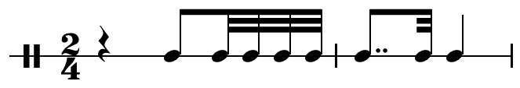  The effect of combining rhythms is again similar to the effect the Impressionist painters created – nothing is rhythmically clear-cut.
Question One cont’d
Question | Achievement | Achievement with Merit | Achievement with Excellence
 | Form / Structure  Debussy develops many of his compositions in a “mosaic” pattern, with short motifs presented in various combinations. He tries to give the impression that the form is fluid. | Form / Structure  Debussy develops many of his compositions in a “mosaic” pattern, with short motifs presented in various combinations. He tries to give the impression that the pieces flow without obvious structure, but when analysed the opposite is the case. A good example of this mosaic structure is “Voiles” (bars 48–64) where motifs are presented in several combinations.  The structure is also determined by use of scale. The opening and closing sections of “Voiles” are pentatonic, while contrast in the middle section is achieved through use of the whole-tone scale. | Form / Structure  Debussy develops many of his compositions in a “mosaic” pattern, with short motifs presented in various combinations. He tries to give the impression that the pieces flow without obvious structure, but when analysed the opposite is the case. A good example of this mosaic structure is “Voiles” (bars 48–64) where motifs are presented in several combinations. He cleverly combines a pedal note with motifs built on earlier melodies – for example a glissando ostinato and secundal chords. The effect is for the piece to seem to flow seamlessly from one combination to another like the coloured stones in a mosaic.

Question | Achievement | Achievement with Merit | Achievement with Excellence
TWO | Work: “Bohemian Rhapsody”  Composer: Freddie Mercury  Genre / Style / Period: Progressive Rock
(a) | Identification of features of the work that are typical of the genre / style / period.
- Improvisation
- Structure of contrasting sections
- Wide variety of timbres
(b) | Brief explanation of the use of typical feature(s), supported by simple evidence. | In-depth explanation of the use of the typical feature(s), supported by specific evidence. | Comprehensive explanation of the use of the typical features, supported by perceptive evidence.  Evaluation of the importance of the feature(s) in showing that the work is representative of the genre / style / period, supported by perceptive evidence.
 | Improvisation  After the ballad there is an electric guitar solo played by Brian May, which is typical of rock music. | Improvisation  At the end of the ballad section the band builds in intensity into a guitar solo of quick, often sequential notes played by Brian May, which serves as a bridge between the ballad and the opera section. | Improvisation  At the end of the ballad section the band builds in intensity into a guitar solo of quick, often sequential notes played by Brian May, which serves as a bridge between the ballad and the opera section. This is typical of the music of the time, although the sequential melody is more lyrical than many other solos of the era.  Evaluation: The solo is important as it serves as a bridge between the ballad and the opera section, helping the modulation from Bb to A, and also providing a link between the two contrasting styles. It is a typical feature of many rock styles also provides a smooth link between the contrasting sections.
 | Structure of contrasting sections  Rather than a typical rock verse-chorus, “Bohemian Rhapsody” is made up of six contrasting sections in a variety of styles. These include an a capella introduction, a ballad, a guitar solo, an operatic section, a hard rock section, and a ballad outro. | Structure of contrasting sections  Typical of the progressive rock genre, “Bohemian Rhapsody” avoids the common popular music verse-chorus structure and is instead made up of six contrasting sections in very contrasting styles drawn from many types of music. These include an a capella introduction, a ballad section linked with a guitar solo to a pseudo-operatic section, a hard rock interlude and back to a ballad outro in a style of similar to the first section, which dies away to tam-tam ending. | Structure of contrasting sections  Typical of the progressive rock genre, “Bohemian Rhapsody” avoids the common popular music verse-chorus structure and is instead made up of six contrasting sections in very contrasting styles drawn from many types of music. These include an a capella introduction, a ballad section linked with a guitar solo to a pseudo-operatic section, a Hard Rock interlude and back to a ballad outro in a style of similar to the first section, which dies away to tam-tam ending.  Evaluation: The widely contrasting styles are very typical of the genre and show a desire to bring together many traditions, using solos to bind them and to contrast with more typical pop / rock verse-chorus forms of the time. Their widely differing natures were also designed to provide drama – an element of dreamy fantasy and spectacle in live performance.

Question Two cont’d
Question | Achievement | Achievement with Merit | Achievement with Excellence
 | Wide variety of timbres  “Bohemian Rhapsody” uses solo vocals, an a capella choir, piano, bass, electric guitar, drum kit, timpani, and tam-tam. | Wide variety of timbres  The intro begins with a choral a capella four-part harmony section and is then followed by a piano ballad section accompanied by bass, electric guitars, and drums.  An electric guitar plays a solo leading into an operatic section, which again uses four-part harmony.  This is followed by a hard rock section in which the electric guitar is highlighted, returning to a piano ballad style before concluding with the sound of a tam-tam. | Wide variety of timbres  The intro begins with a choral a capella four-part harmony section using multi-track recordings of Freddie Mercury.  The ballad section (0:49) highlights the piano, guitars and drum kit, with the guitar mimicking the piano.  A guitar solo leads into an operatic section (c. 3:00) in four-part harmony that uses more multi tracking and overdubs.  This contrasts with the hard rock section (4:00), which in turn contrasts with the return of the piano ballad and the finality of the tam-tam that relieves the tension at the end.’  Evaluation: Typical of this genre is the use of strikingly contrasting timbres and experimentation or pushing the boundaries with multi-tracking and overdubbing of instruments and voices. These were both difficult to do and required a great deal of time with the technology of the 1970s (eg reel-to-reel tape recorders). The timbres of “Bohemian Rhapsody” and similar pieces are the forerunners of many of the effects in the music of today.

Question | Achievement | Achievement with Merit | Achievement with Excellence
THREE
(a) | Brief explanation of the importance of a contextual factor in the first performance of one of the works, supported by simple evidence | In-depth explanation of the importance of a contextual factor in the first performance of one of the works, supported by specific evidence. | Comprehensive explanation of the importance of a contextual factor in the first performance of one of the works, supported by perceptive evidence
 | Effect of social / historical / cultural events on the first performance of Debussy’s Préludes: The Franco-Prussian War  The French defeat in the Franco-Prussian War caused French suspicion of Germany. French composers including Debussy reacted against many of the features of the German Romantic style and developed a new type of composition that is seen in the Préludes. | Effect of social / historical / cultural events on the first performance of Debussy’s Préludes: The Franco-Prussian War  Because of the French defeat in the Franco-Prussian War, French composers viewed German Romanticism with suspicion. This was a reason for Debussy to explore a different style that was less rhythmical and moved further away from a strong sense of key. This can be seen in the style of the Préludes, for example in the use of rests to upset the beat. | Effect of social / historical / cultural events on the first performance of Debussy’s Préludes: The Franco-Prussian War  Because of the French defeat in the Franco-Prussian War, French composers viewed German Romanticism with suspicion. This was a reason for Debussy to explore a different style that was more rhythmically fluid, and moved further away from diatonic tonality and a strong sense of key. This can be seen in “Voiles” where the opening is based on a whole-tone scale, and in the use of parallel thirds and fourths. Rhythmic fluidity is shown when rests begin to upset the regular pulse typical of other music of the day.
 | Effect of resources available at the time on the first performance of Queen’s “Bohemian Rhapsody”: Multi-track recording  The opening a capella section and the operatic section of this piece were revolutionary for the time. They involve multiple takes of Freddie Mercury singing dubbed over one another.  In the operatic section, three of the band members sing, and these takes were overdubbed together. | Effect of resources available at the time on the first performance of Queen’s “Bohemian Rhapsody”: Multi-track recording  The opening a capella section and the operatic section of this piece were revolutionary for the time. They involve multiple takes of Freddie Mercury singing dubbed over one another.  In the operatic section, three of the band members sing, and these takes were overdubbed together.  For the time, this was a technically demanding process, and the opera section alone took nearly three weeks to complete.  These vocal features of the work caused a sensation, but created problems in live performances where it was difficult to reproduce the effects using the technical equipment of the time. | Effect of resources available at the time on the first performance of Queen’s “Bohemian Rhapsody”: Multi-track recording  The opening a capella section and the operatic section of this piece were revolutionary for the time. They involve multiple takes of Freddie Mercury singing dubbed over one another.  In the operatic section, three of the band members sing, and these takes were overdubbed together. The band was trying to create a “wall of sound”. They also used “bell” effects for words such as ‘magnifico’.  These vocal features of the work caused a sensation, but created problems in live performances where it was difficult to reproduce the effects using the technical equipment of the time – in fact this led to many performances of “Bohemian Rhapsody” beginning with the ballad section (“Mama…”). However, these effects contributed to the spectacle, glamour, and originality of “Bohemian Rhapsody”.

Question Three cont’d
Question | Achievement | Achievement with Merit | Achievement with Excellence
(b) | Brief explanation of how texture or tonality has been used in one of the works, supported by simple evidence. | In-depth explanation of how texture or tonality has been used in one of the works, supported by specific evidence. | Comprehensive explanation of how texture or tonality has been used in one of the works, supported by perceptive evidence
 | Texture: Préludes  Debussy often uses a three-part texture consisting of a pedal bass note or low bass chords contrasting with chords in a much higher register.  He then has a main melody in the middle. He often uses parallel chords in a technique called “planing”. | Texture: Préludes  Debussy often uses a three-part texture consisting of a pedal bass note or low bass chords contrasting with chords in a much higher register.  He then has a main melody in the middle. A good example of this is the “planing” section in “Danseuses de Delphes” (bars 11–12). Above a low held F, there is a high falling stepwise melody, and between them a series of rising chords in the middle. | Texture: Préludes  Debussy often uses a three-part texture consisting of a pedal bass note or low bass chords contrasting with chords in a much higher register.  He then has a main melody in the middle. A good example of this is the “planing” (parallelism) section in “Danseuses de Delphes” (bars 11–12). Above a low held F, there is a high falling stepwise melody, and between them a series of rising consecutive root-position chords in the middle:  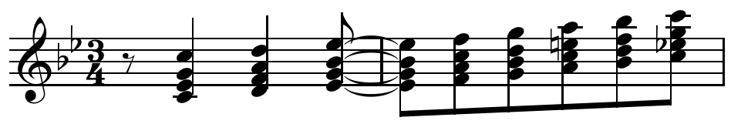  This parallel root-position sound, which can also be found extensively in “La cathédrale engloutie”, gives many of his pieces a “modal” feel.
 | Tonality: “Bohemian Rhapsody”  “Bohemian Rhapsody” begins in Bb major in the intro and into the ballad section (also Ab). It changes to A major for the operatic section, then moves to Eb, and finally to F. | Tonality: “Bohemian Rhapsody”  “Bohemian Rhapsody” begins in Bb major in the intro, although this is made a little unstable by some 7th and diminished chords. The ballad section is more stable in Bb before the operatic section. This section is less stable and moves chromatically. The key is confirmed by a dominant pedal on Bb at “Let me go”, which resolves eventually to Eb for the guitar solo, where it stays for the rest of the song until the end where it finishes in F. | Tonality: “Bohemian Rhapsody”  “Bohemian Rhapsody” begins in Bb major in the intro, although this is made a little unstable by some 7th and diminished chords. The ballad section is more stable in Bb before the Operatic section. This section is less stable owing to the chromatic movement at ”I’m just a poor boy” (B, Bb, A, Bb). The key is confirmed by a dominant pedal on Bb at “Let me go”, which resolves eventually to Eb for the guitar solo where it stays for the rest of the song until the end where it finishes in F.

Question Three cont’d
Question | Achievement | Achievement with Merit | Achievement with Excellence
(c) |  |  | Discussion of a similarity or difference in the use of an element, device, or technique in the works, supported by perceptive evidence.
Harmony: “Bohemian Rhapsody”
The song uses a range of typical pop / rock chords.
The intro a capella section makes great use of 7th and 6th chords and occasionally diminished chords, which contrasts with the mainly major and minor chords of the ballad section.
The operatic section is often more complex and the chords change frequently, for example at “He’s just a poor boy”, the chords used are Ab/Eb, Eb, Ebdim, Eb.

Harmony: Préludes
Similarly Debussy also uses 6th, 7th, and diminished chords, as well as 9th chords. But in other respects the harmony often sounds very different. Using chords based on the whole-tone scale gives very different sound as the chords are all augmented, and the music lacks a firm key-centre.
For example, in bar 14 of “La cathédrale engloutie” augmented chords result from the use of the whole-tone scale.
Debussy sometimes mixes together chords based on different scales. For example in the “Danses de Delphes”, a Bb chord is followed by with two whole-tone chords:
